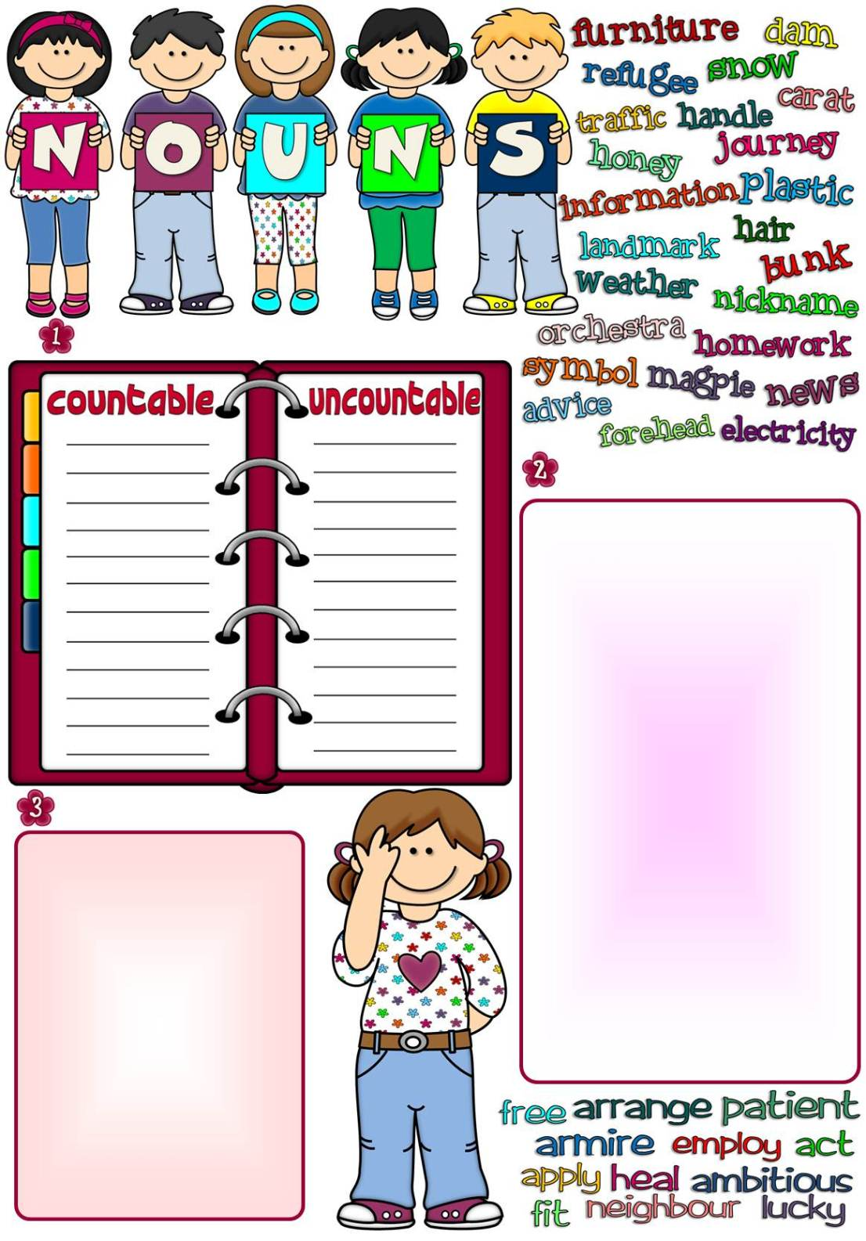
boy
story
woman
dwarf
bus
goose
wolf
bear
table
plant
deer
witch
gallery
hero
Write the plural forms of the nouns.
Use the words listed below to form the nouns and complete the sentences.
Put the nouns in the correct column.
Mike is a temporary _ _ _ _ _ _ _ _ in his dad’s marketing company.
I wish you good _ _ _ _ _ _ _ _ with your driving test.
Being a teacher requires o lot of _ _ _ _ _ _ _ _ .
My mum has great _ _ _ _ _ _ _ _ for Madonna as a singer.
I’ve already filled in the _ _ _ _ _ _ _ _ form my passport.
We should include more vegetables in our diet. They are good for our _ _ _ _ _ _ _ _.
Playing football is one of the most popular outdoor _ _ _ _ _ _ _ _ .
In democratic countries _ _ _ _ _ _ _ _ of speech is guaranteed by the constitution.
James’s greatest _ _ _ _ _ _ _ _ in life is to become an actor.
10. My brother does exercise in the
nearby _ _ _ _ _ _ _ _ center twice a
week.
11.The Lawsons would like to move to a
quiet, residential _ _ _ _ _ _ _ _ .
12. I’ve made all the _ _ _ _ _ _ _ _ for the
trip to Africa.

boy
story
woman
dwarf
bus
goose
wolf
bear
table
plant
deer
witch
gallery
hero
Write the plural forms of the nouns.
Use the words listed below to form the nouns and complete the sentences.
Put the nouns in the correct column.
Mike is a temporary _ _ _ _ _ _ _ _ in his dad’s marketing company.
I wish you good _ _ _ _ _ _ _ _ with your driving test.
Being a teacher requires o lot of _ _ _ _ _ _ _ _ .
My mum has great _ _ _ _ _ _ _ _ for Madonna as a singer.
I’ve already filled in the _ _ _ _ _ _ _ _ form my passport.
We should include more vegetables in our diet. They are good for our _ _ _ _ _ _ _ _.
Playing football is one of the most popular outdoor _ _ _ _ _ _ _ _ .
In democratic countries _ _ _ _ _ _ _ _ of speech is guaranteed by the constitution.
James’s greatest _ _ _ _ _ _ _ _ in life is to become an actor.
10. My brother does exercise in the
nearby _ _ _ _ _ _ _ _ center twice a
week.
11.The Lawsons would like to move to a
quiet, residential _ _ _ _ _ _ _ _ .
12. I’ve made all the _ _ _ _ _ _ _ _ for the
trip to Africa.

boyboys
storystories
womanwomen
dwarfdwarfs
busbuses
goosegeese
wolfwolves
bearbears
tabletables
plantplants
deerdeer
witchwitches
gallerygalleries
heroheroes
3. Write the plural forms of the nouns.
2. Use the words listed below to form
the nouns and complete the
sentences.
1. Put the nouns in the correct column.
Mike is a temporary employee in his dad’s marketing company.
I wish you good luck with your driving test.
Being a teacher requires o lot of patience.
My mum has great admiration for Madonna as a singer.
I’ve already filled in the application form my passport.
We should include more vegetables in our diet. They are good for our health .
Playing football is one of the most popular outdoor activities .
In democratic countries freedom of speech is guaranteed by the constitution.
James’s greatest ambition in life is to become an actor.
10. My brother does exercise in the
nearby fitness center twice a
week.
11.The Lawsons would like to move to a
quiet, residential neighbourhood .
12. I’ve made all the arrangements for the
trip to Africa.
Answers
countable
uncountable
journey
bunk
dam
refugee
nickname
landmark
symbol
carat
handle
orchestra
forehead
information
furniture
snow
news
weather
homework
honey
electricity
plastic
traffic
advice
hair

