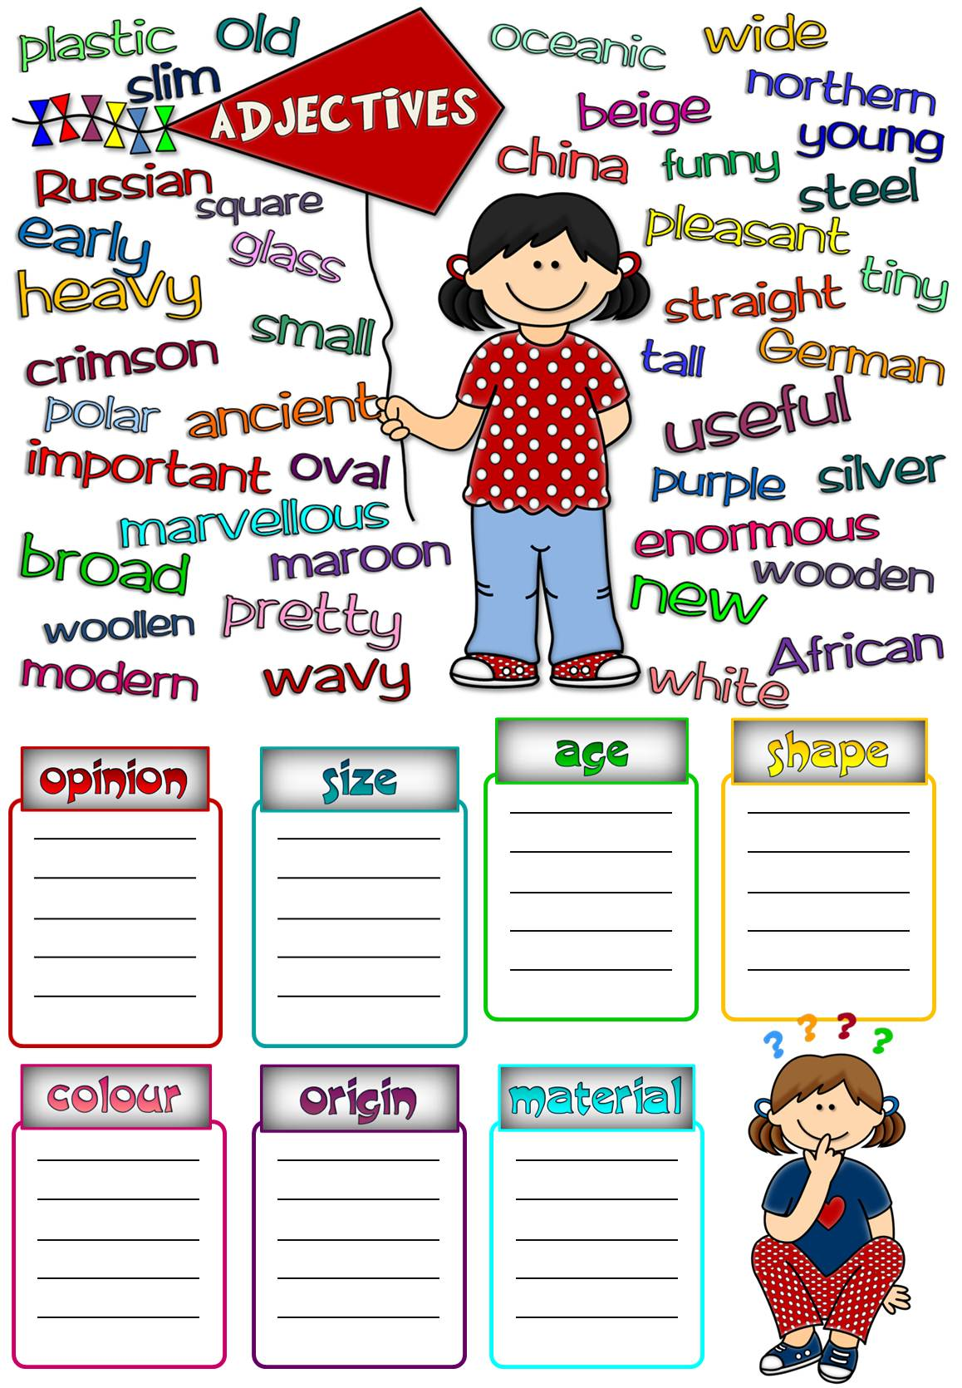

Group the adjectives according to the types.

Group the adjectives according to the types.

Answers
important
pleasant
pretty
marvellous
funny
useful
enormous
heavy
slim
tiny
small
tall
ancient
modern
old
mew
young
early

wide
straight
square
oval
broad
wavy
silver
maroon
purple
white
beige
crimson

German
Russian
African
Northern
polar
oceanic
glass
plastic
woollen
wooden
china
steel
opinion
size
age
shape
colour
origin
material

